**Ministry of Higher Education and Scientific Research and Computing and Communication Technologies**

Translated from French to English - www.onlinedoctranslator.com

**General Directorate of Technological Studies**

**Higher Institute of Technological Studies of Bizerte**

**IT technology department**

**INTEGRATION PROJECT REPORT**

**Topic:**

**Development of a web and mobile event management application**

**Made by:**

* WEDA MOSSAB
* LAMOUCHI SALMA
* NOOMENE HAJER
* MEKNI HAMED

**Framed by:**

* Mrs. GAFSI AFEF

**College year: 2022/2023**

[**ACKNOWLEDGMENT**](https://www.linguee.fr/anglais-francais/traduction/acknowledgment.html)

It is important to begin this report by expressing our deep gratitude to all those who have supported us throughout this period.

We thank our supervisor Mrs. Gafsi Afef who accompanied us throughout this experience, for her help and her precious advice. We wish her a lot of success and perspective.

We would also like to thank all our teachers Maatoug Nizar and Jridi Khaoula for being very patient and pedagogical in accompanying us during this experience. May these few words convey the deep admiration and gratitude we feel for you.

**SOMMAIRE**

**Table des matières**

Chapter 1: Presentation of the project 9

Introduction 10

1. project framework 10

1.1. Context of the project 10

2. Study of the existing 10

2.1. Description of the existing 10

2.2. Reviews of the existing 10

3. Suggested solutions 11

4. Methodology and modeling adopted 11

4.1. Modeling language UML: 11

4.2. Framework SCRUM: 11

Chapter 2: Preliminary Study 12

Introduction 13

1. Requirements Specification: 13

1.1. Functional requirements: 13

1.2. Non-functional requirements: 14

3. Product Backlog 14

4. Global Use Case Diagram: 16

16

5. Environnement de travail 17

5.1. Hardware environment: 17

5.2. Software environment 17

Conclusion 22

Chapter 3: Sprint 1 23

Introduction 24

1. Sprint Planning 24

2. Sprint Goal 24

3. Sprint Backlog 24

4. Analysis of sprint1 26

4.1. Use Case diagram 26

5. Sprint 1 design 28

5.1. Class Diagram 28

5.2. Sequence diagrams 29

5.1.2. Sequence diagram (delete event): 30

6. Sprint Review 30

Conclusion : 34

Chapter 4: Sprint 2 35

Introduction 36

1. Sprint Planning 36

2. Sprint Goal 36

3. Sprint Backlog 36

4. Analysis of sprint 2 37

4.1. Use Case diagram 37

5. Sprint 2 design 39

5.1. Class Diagram 39

5.2. Sequence diagrams 40

5.1.2. Sequence diagram (Student register): 41

6. Sprint Review 41

Conclusion: 46

Chapter 5: Sprint 3 47

Introduction 48

1. Sprint Planning 48

2. Sprint Goal 48

3. Sprint Backlog 48

4. Analysis of sprint 3 49

4.1. Use Case diagram 49

5. Sprint 3 design 51

5.1. Class Diagram 51

5.2. Sequence diagrams 52

5.1.2. Sequence diagram (Contact Admin): 53

6. Sprint Review 53

Conclusion: 56

General Conclusion 58

**Liste des Figures**

**Figure 1: Global Use Case Diagram** 14

Figure 2: Visual Studio Code Logo 15

Figure 3:Visual Paradigm Logo 16

Figure 4: KEYCLOAK Logo 16

Figure 5: Bootstrap Logo 17

Figure 6: Angular Logo 17

Figure 7: Flutter Logo 18

Figure 8: Spring Boot Logo 18

Figure 9: Express Js Logo 19

Figure 10: MongoDB Logo 19

Figure 11: Sprint 1 Use Diagram: 24

Figure 12: Sprint 1 Class Diagram 25

Figure 13: Add event Sequence Diagram 26

Figure 14: Delete Event Sequence Diagram 27

Figure 15: Add Event Web 28

Figure 16: home page 28

Figure 17: Consult events 29

**Figure 18: Sprint 2 Use Diagram** 34

**Figure 19: Sprint 2 Class Diagram** 35

**Figure 20: Student Participation** 36

**Figure 21: Student register Sequence Diagram** 37

**Figure 22: Sign in Student** 38

Figure 23: home page 38

Figure 24: Consult events 39

**Figure 25: Sprint 3 Use Diagram** 44

**Figure 26: Sprint 3 Class Diagram** 45

**Figure 27: Student Participation** 46

**Figure 28: Update Profile** 46

**Figure 29: Contact Admin** 47

**Figure 30: Contact Admin** 48

Figure 31: home page 48

Figure 32: Consult events 49

**Liste des Tableau**

**Table 1 : Product Backlog 15**

**Table 2: Computer features 17**

**Table 3 : BackLog Sprint 1 25**

**Table 4: BackLog Sprint 2 36**

**Table 5: Backlog Sprint 3 48**

**Table 6: Backlog Sprint 4 58**

# Chapter 1: Presentation of the project

## Introduction

In this chapter we will explain the operating principles of our application and propose solutions for the problems found. Since the design of a computer system is a very important step that will influence the quality and reliability of any application.

## 1. project framework

### 1.1. Context of the project

This project is realized within the framework of the integration project. The duration of the project is 2 months, during which we must realize the design and development of the requested functionalities.

## 2. Study of the existing

### 2.1. Description of the existing

While discussing between them we noticed that there are problems at the level of management of the events in our institute, especially the events of the clubs.

Those problems will affect mediating events in order to obstruct them.

### 2.2. Reviews of the existing

The institute page is a globally administrative page so publish these events in which it is not possible to ensure that they will be seen by the students.

In each event the administration does not manage to know the exact number of students who will participate and their data (Name, First name, CIN…).

An increase in the consumption of paper used to make event posters that will be destroyed later.

## 3. Suggested solutions

The team members and I decided to develop an application that contains a mobile and web version to facilitate the management of events in our institute. This project has a user part (the student) who must create an account to participate in any event and know all their details. And

another administrative part in which the administration will manage the events and see the list of participants and the approved ones.

The university administrator’s system must be operational, scalable, user-friendly and provide the necessary real-time information.

For this, the system to be implemented must meet the requirements of all users. In the following, we present all functional and non-functional system requirements.

## 4. Methodology and modeling adopted

A development methodology is a framework used to plan and structure the development of a development of an application. To do this, it is necessary to process and model a system before it’s to understand its functioning and ensure its coherence.

### 4.1. Modeling language UML:

UML for Unified Modeling Language is a graphical modeling language designed to understand and describe needs, specify, and document systems, sketch software architectures, design solutions and communicate points of view.

### 4.2. Framework SCRUM:

The agile framework we will adopt is Scrum. It represents the most agile approach to using existing agile approaches and is simple to understand.

The principle of SCRUM is to focus the development team on a set of functionalities to be carried out iteratively, in iterations lasting from two to four weeks, called Sprints.

Each Sprint must result in the delivery of a partial product called increment.

# Chapter 2: Preliminary Study

## Introduction

In this chapter we will first present the main actors of the application. Next, we will identify the functional and non-functional needs of the project. Afterwards, we will present the Scrum Framework, the Product Backlog, and the sprints sequence. Then we go on to model the overall use case of the project. Finally, we will close the chapter by explaining the hardware and software environment and identifying the application architecture.

## 1. Requirements Specification:

### 1.1. Functional requirements:

These are all the services offered by our system to all its primary actors. In order to meet user requirements, this software must provide the following functionality:

Our platform will offer the student the following features:

**Sign in:** the student can sign in to their account.

**Sign up:** the student can register to a new account.

**Edit your profile:** the student can change their profile information.

**Consult the event list:** the student can consult the list of events.

**Participate in events:** the student can participate in more than one event.

**Contact admin:** the student has the right to contact admin anytime he likes.

Our platform will provide the administrator with the following features:

**Sign in:** the admin can sign in to their account.

**Manage students:**  the admin can modify, add, delete, access students.

**Manage events:** the admin has control over events list.

**Receive messages:** the admin receives messages from event participants.

### 

### 

### 1.2. Non-functional requirements:

Some projects will require a very large amount of work and for other project areas rapid monitoring will be sufficient. At a minimum, the following list can be a useful reminder to ensure you have covered the essentials:

• Speed of processing given the large number of students, it is imperative that the processing time be as close as possible to real time.

• Ergonomics: the application must have a pleasant and homogeneous interface.

• Performance: an application must meet all user requirements in an optimal way.

• Usability: develop an easy-to-use and maintain application. User interfaces must be user-friendly, that is, simple, ergonomic and user-friendly.

• Data security: Our application takes the form of several interfaces whose content allows us to manipulate the data present at the database level.

Since some of this data is confidential, it can only be manipulated after user authentication, so it is important not to allow direct access to the system.

### 3. Product Backlog

This is the set of "User Stories" expressed by the end user of our application and

written and proposed by the Product Owner. This is one of the agile manifestations of SCRUM.

Indeed, it is a living and dynamic artifact as it adapts appropriately to changes in any context:

• Changing needs

• Change in technology

• Market change

As a development team, we always use the Product Backlog and its editor the Product Owner.

We voluntarily choose the appropriate user stories with our personal effort development and we

build our own sprints from the Product Backlog.

|  |  |  |  |  |  |  |  |
| --- | --- | --- | --- | --- | --- | --- | --- |
| **User Story** | | **Type** | **Priority** | **Time estimated** | **complexity** | **Dod** | **Sp** |
| US 0 | Initializing the development enviroment | TS | 1 | 3 Days | 5 | **dev enviroment initialized** | 15 Days |
| US 1 | As admin, i want to add an event | US | 2 | 2 Days | 5 | **admin now can add an event** |
| US 2 | As admin, i want to delete an event | US | 2 | 2 Days | 5 | **admin now can delete an event** |
| US 3 | As admin, i want to read an event | US | 2 | 2 Days | 5 | **admin now can read an event** |
| US 4 | As admin, i want to update an event | US | 2 | 2 Days | 5 | **admin now can update an event** |
| US 5 | As student ,i want to consult the list of events | US | 3 | 4 Days | 5 | **Student can consult th list of events** |
| US 6 | As a student i want to participate in events | US | 4 | 4 Days | 7 | **Student can participate to events** | 15 Days |
| US 7 | As admin , i want to consult the list of participants | US | 5 | 2 Days | 5 | **admin can consult the list of participants** |
| US 8 | As admin , i want to delete students from list . | US | 9 | 2 Days | 5 | **admin can delete students from list** |
| US 9 | As student , i want to sign up | US | 7 | 4 Days | 8 | **student can sign up** |
| US 10 | As student , i want to sign in | US | 7 | 3 Days | 8 | **student can sign in** |
| US 11 | As admin , i want to sign in | US | 6 | 6 Days | 6 | **admin can sign in** | 15 Days |
| US 12 | As admin or student , i want to manage my profile informations | US | 11 | 3 Days | 7 | **both of student and admin can manage their profiles** |
| US 13 | As student , i want to contact the admin | US | 10 | 6 Days | 6 | **student can contact the admin** |
| US 14 | As admin i want to consult the statistics | US | 12 | 7 Days | 7 | **admin can consult the statistics** | 15 Days |
| US 15 | As student ,i want to receive notifications of new events | US | 8 | 8 Days | 6 | **student can receive notifications of new events** |

**Table 1 : Product Backlog**

## 4. Global Use Case Diagram:

## 

**Figure 1: Global Use Case Diagram**

## 5. Environnement de travail

### 5.1. Hardware environment:

We developed our application using four laptop computers including technical characteristics are described below:

|  |  |  |  |  |
| --- | --- | --- | --- | --- |
| **laptop** | **1** | **2** | **3** | **4** |
| **owner** | mossab weda | ahmed mekni | hajer noomane | salma lamouchi |
| **processor** | Core i3 | Core i5 | Core i3 | Core i5 |
| **RAM** | 16Go |  | 8Go | 8Go |
| **hard disk** | 1To |  | 1To | 1To |
| **operating system** | Windows 10 (x64) |  | Windows 10 (x64) | Windows 10 (x64) |

Table : Computer features

### 5.2. Software environment

#### 5.2.1. Code editor software:



.

Figure : Visual Studio Code Logo

* **Visual Studio** **Code:** is an open-source code editor developed by Microsoft for Windows, Linux and Mac OS supporting a very large number of languages through extensions.



Figure :Visual Paradigm Logo

* **Visual paradigm**: it is an intelligent, online diagram editor that facilitates the creation of diagrams.

Figure : KEYCLOAK Logo

* **Keycloak**: is an open-source software that provides a single authentication method through identity and access management.

#### 5.2.2. Frameworks and Database:

Figure : Bootstrap Logo

* **Bootstrap:** is a CSS framework. A Framework is a set of libraries grouped for a specific purpose and having internal rules that users must follow.



Figure : Angular Logo

* **Angular:** is an open-source framework developed by Google, written in JavaScript that allows the creation of Web applications



Figure : Flutter Logo

* **Flutter:** is an open-source user interface software development kit created by Google. created by Google. It is used to develop applications for Android, iOS, Linux, Mac, Windows and the web from a single code base.



Figure : Spring Boot Logo

* **Spring Boot**: is a JAVA development framework. It is a variation of the classical framework of Spring that allows essentially to realize microservices (most of the time web services are grouped in API).



Figure : Express Js Logo

* **Express JS:** is a framework for building web applications based on Node.js. It is in fact the standard framework for server development in Node.js.



Figure : MongoDB Logo

* **MongoDB:** is a document-oriented database management system that can be distributed to any number of computers and does not require a predefined data schema

## 

## 

## Conclusion

The specification of the needs allowed us to have a clearer vision of the subject and a deeper understanding of the tasks to be performed. We have tried to describe throughout this chapter briefly the basic functionalities of the system, the technical choices, the development, and design tools.

In the next chapter we start the development of the first sprint.

# Chapter 3: Sprint 1

### 

## Introduction

This chapter presents the first sprint of the project which is the initialization of the environment, the CRUD of the event by the admin and the consultation of the event list by the student.

## Sprint Planning

The Sprint Planning is a collaborative work of the Scrum Team, it is the initial step of any Sprint, it lasts 4 hours, during which we set the Sprint Goal and the Sprint Backlog.

## Sprint Goal

The goal of this sprint is event management and consultation by the student.

## Sprint Backlog

Once we have defined the goal of our sprint, it's time to decide which features and features and their degree of importance are included in the sprint.

|  |  |  |  |  |
| --- | --- | --- | --- | --- |
| **User Story** | | **Tasks** | **Owner** | **Time estimated** |
| **Sprint 1** | **US 0 : Initializing the development enviroment** | Create the DataBase | Hajer | 1/2 Day |
| Install Angular Project | Salma | 1/2 Day |
| Install Spring Boot Project | Salma | 1/2 Day |
| Install Node Js Project | Ahmed | 1/2 Day |
| Install Flutter Project | Mossab | 1/2 Day |
| Initialize Our Project in Github | Hajer | 1/2 Day |
| **US 1-4 : As admin, i want to manage events(add,delete,update,read)** | Create the class Diagram | Mossab + Ahmed | 1/2 Day |
| Create the Use Case Diagram | Hajer | 1/2 Day |
| Create the Sequence Diagrams | mossab | 1 Day |
| Generate CRUD Component (Angular) | salma | 2 Days |
| Build the CRUD interface with Flutter | hajer | 2 Days |
| Generate Event Managment micro-service (Spring Boot) | ahmed | 1 Day |
| **US 5 : As student ,i want to consult the list of events** | Generate the event-list Component (Angular) | salma | 1 Day |
| Generate the show-event Component (Angular) | salma | 1 Day |
| Build the events list interface with Flutter | hajer | 1 Day |
| Create Event-list micro-service (Node Js) | Mossab | 1 Day |

**Table 3 : BackLog Sprint 1**

## Analysis of sprint1

### 4.1. Use Case diagram

The use case diagram is a functional diagram that shows the interactions of the system to be interactions of the system to be developed with its users.

##### 

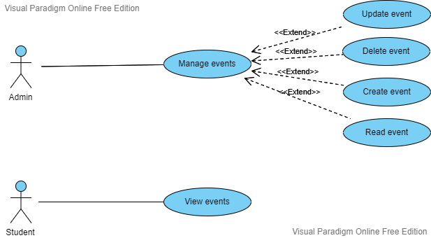

**Figure 11: Sprint 1 Use Diagram:**

## Sprint 1 design

### 5.1. Class Diagram

**Figure 12: Sprint 1 Class Diagram**

### 5.2. Sequence diagrams

#### 5.1.1. Sequence diagram (add event):

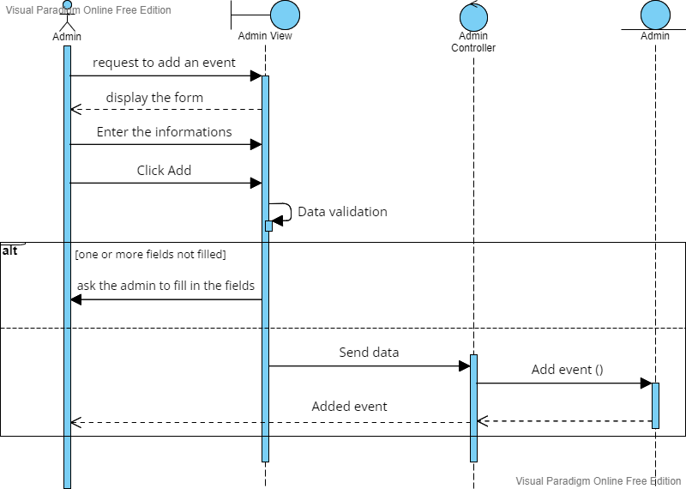

##### 

**Figure 13: Add event Sequence Diagram**

### 

### 5.1.2. Sequence diagram (delete event):

**Figure 14: Delete Event Sequence Diagram**

## Sprint Review

The Sprint Review is held at the end of each Sprint to demonstrate the increment, inspect it and adapt the Product Backlog if necessary.

In the following, we will build the resulting increment this Sprint.

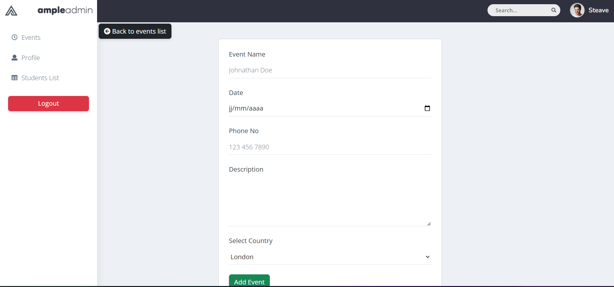

**Figure 15: Add Event Web**

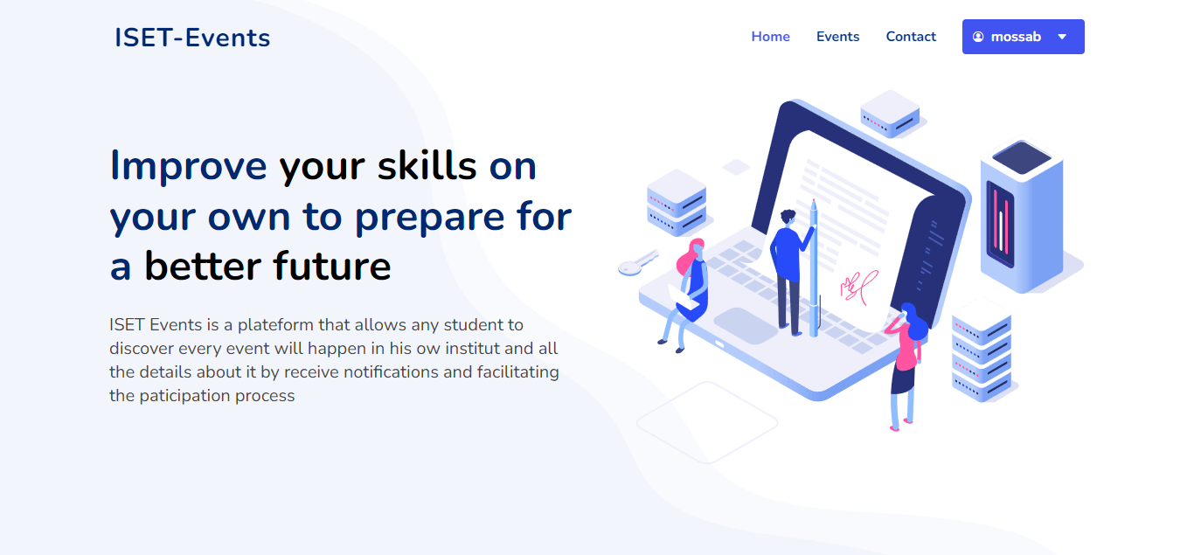

**Figure 16: home page**

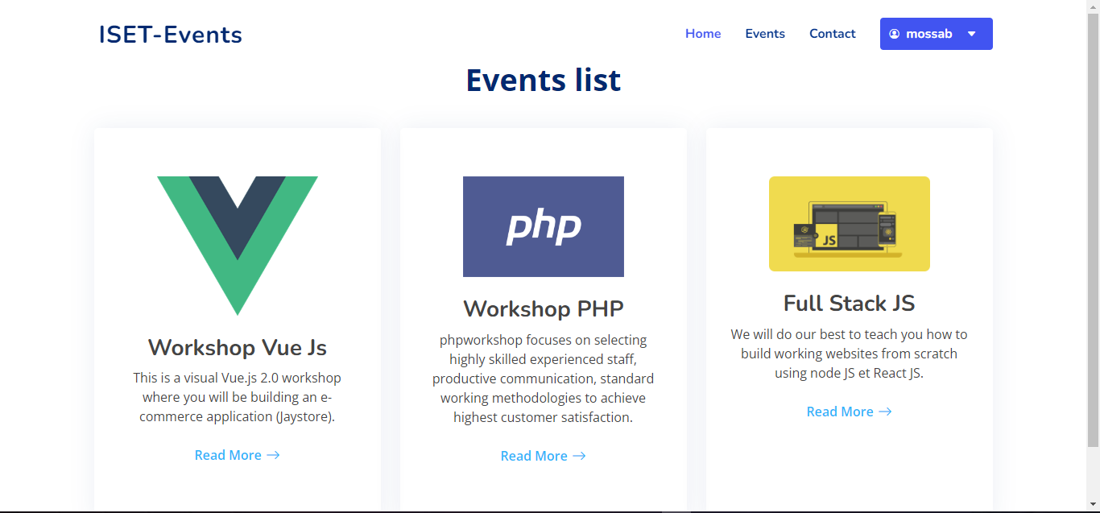

**Figure 17: Consult events**

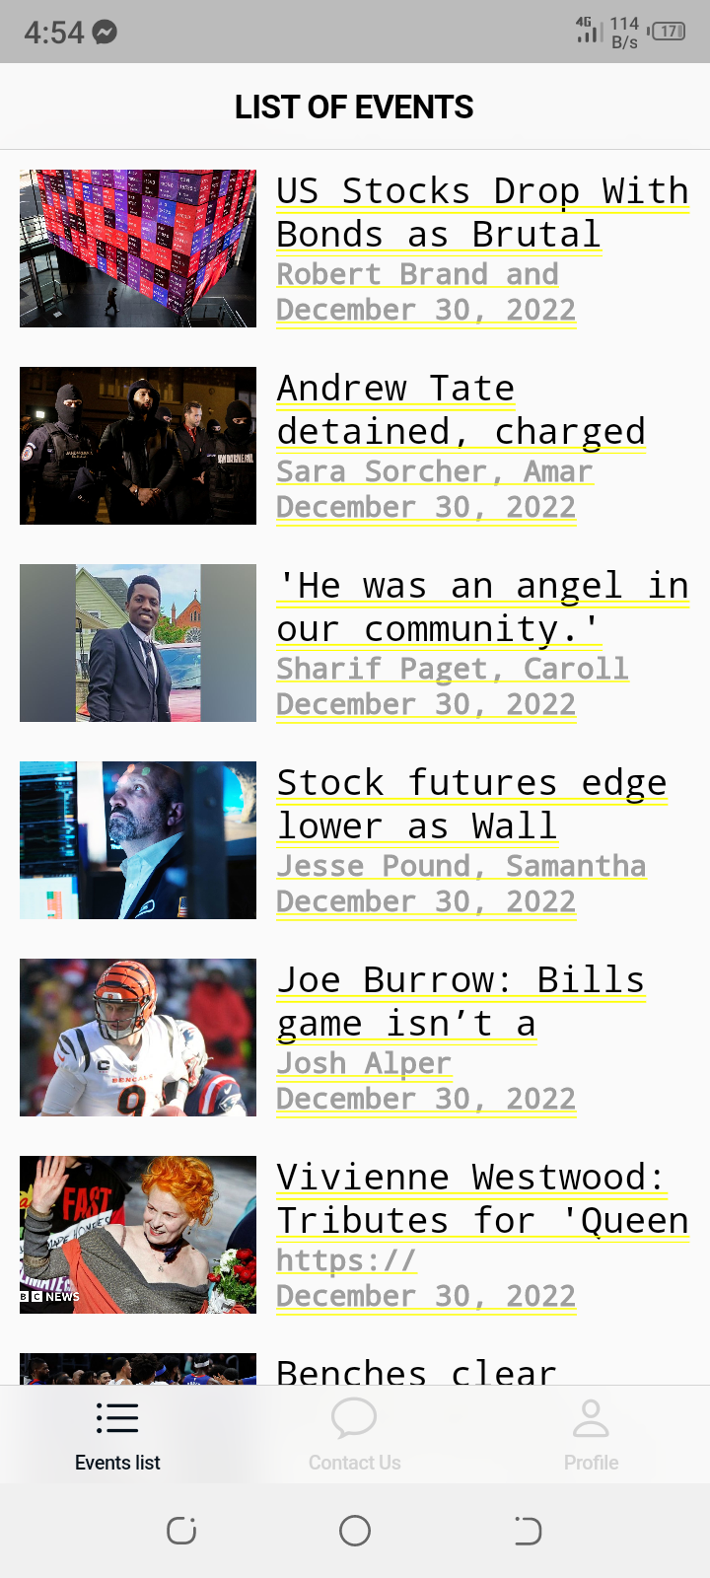

**Figure 18: List of events mobile**

## Conclusion :

This chapter details the first sprint. It details the analysis, design and construction of the incremental steps. The next chapter introduces the second sprint.

# Chapter 4: Sprint 2

## Introduction

The objective of this chapter is to present the work completed during the second sprint of our project. In this part, we focus on two tasks being the participation in the events and the authentication of the student. The sprint study covers the analysis, the design, the realization and the functional tests...

## Sprint Planning

The Sprint Planning is a collaborative work of the Scrum Team, it is the initial step of any Sprint, it lasts 4 hours, during which we set the Sprint Goal and the Sprint Backlog.

## Sprint Goal

The goal of this sprint is event participation and the student authentification.

## Sprint Backlog

Once we have defined the goal of our sprint, it's time to decide which features and features and their degree of importance are included in the sprint.

|  |  |  |  |  |
| --- | --- | --- | --- | --- |
| **User Story** | | Tasks | Owner | **Time estimated** |
| **Sprint 2** | **US 6 : As a student i want to participate in events** | Create th class diagram | hajer | 1/2 Day |
| Create the Use Case Diagram | ahmed | 1/2 Day |
| Create the Sequence Diagram | mossab | 1 Day |
| Create Event-Participation micro-service (Node Js) | mossab | 1 Day |
| Generate Participation Form (Angular) | Salma | 1 Day |
| Build the participation form with flutter | hajer | 1 Day |
| **US 7 : As admin , i want to consult the list of participants** | Generate the participations-list Component (Angular) | Mossab | 1 Day |
| Create Event-participation service (Spring Boot) | ahmed | 1 Day |
| Build events interface with flutter | hajer | 1 Day |
| **US 8 : As admin , i want to delete students from list** | Create Participation Managment service (Spring Boot) | ahmed | 1 Day |
| **US 9 : As student , i want to sign up** | Create the inetface of Sign up (Angular) | Salma | 1 Day |
| Create the inetface of Sign up (Flutter) | hajer | 1 Day |
| Make the authentification with Keycloack | Mossab | 1 Day |
| **US 10 : As student , i want to sign in** | Generate the student Sign in component (Angular ) | Salma | 1 Day |
| Build the Log in page for student (flutter) | hajer | 1 Day |
| Verify the authentification with keycloack | mossab | 1 Day |

**Table 4: BackLog Sprint 2**

## Analysis of sprint 2

### 4.1. Use Case diagram

The use case diagram is a functional diagram that shows the interactions of the system to be interactions of the system to be developed with its users.

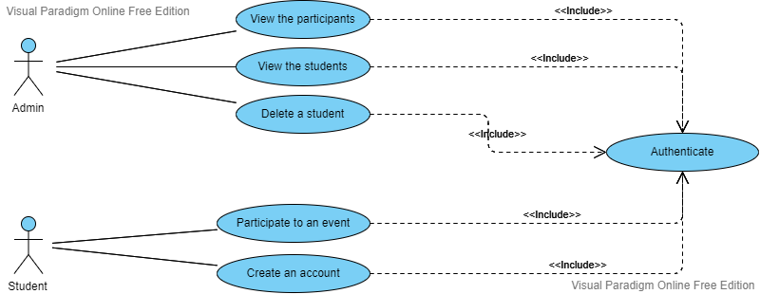

**Figure 19: Sprint 2 Use Diagram**

## Sprint 2 design

### 5.1. Class Diagram

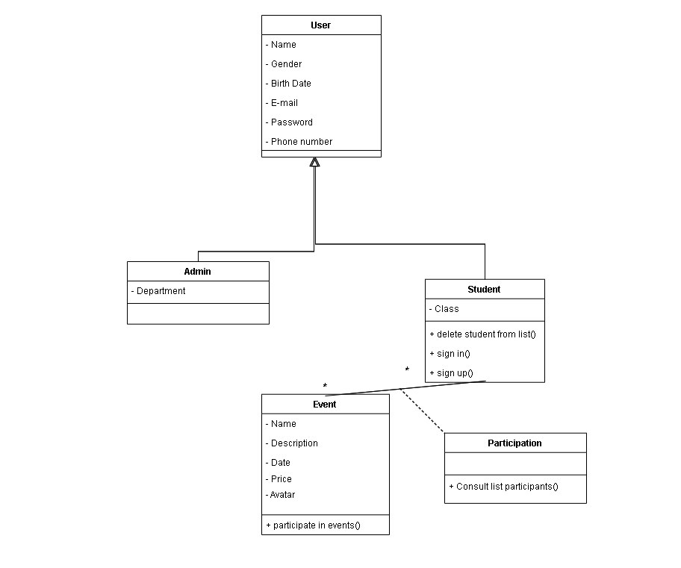

**Figure 20: Sprint 2 Class Diagram**

### 5.2. Sequence diagrams

#### 5.1.1. Sequence diagram (Student participation):

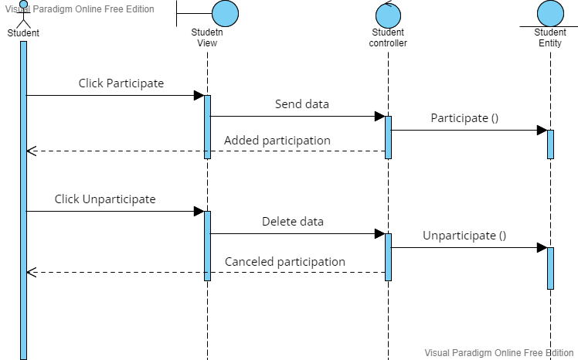

##### l

**Figure 21: Student Participation**

### 5.1.2. Sequence diagram (Student register):

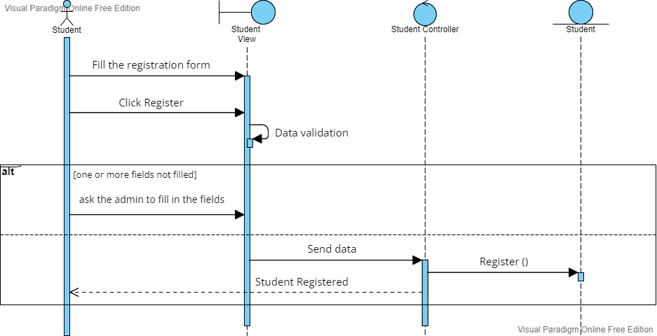

**Figure 22: Student register Sequence Diagram**

## Sprint Review

The Sprint Review is held at the end of each Sprint to demonstrate the increment, inspect it and adapt the Product Backlog if necessary.

In the following, we will build the resulting increment this Sprint.

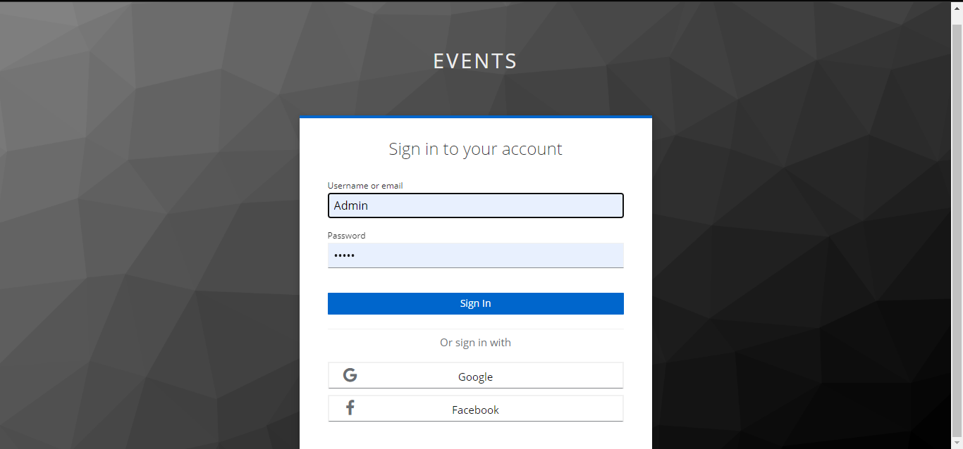

**Figure 23: Sign in Student**



**Figure 24: home page**



**Figure 25: Consult events**



**Figure 26: Sign up mobile**

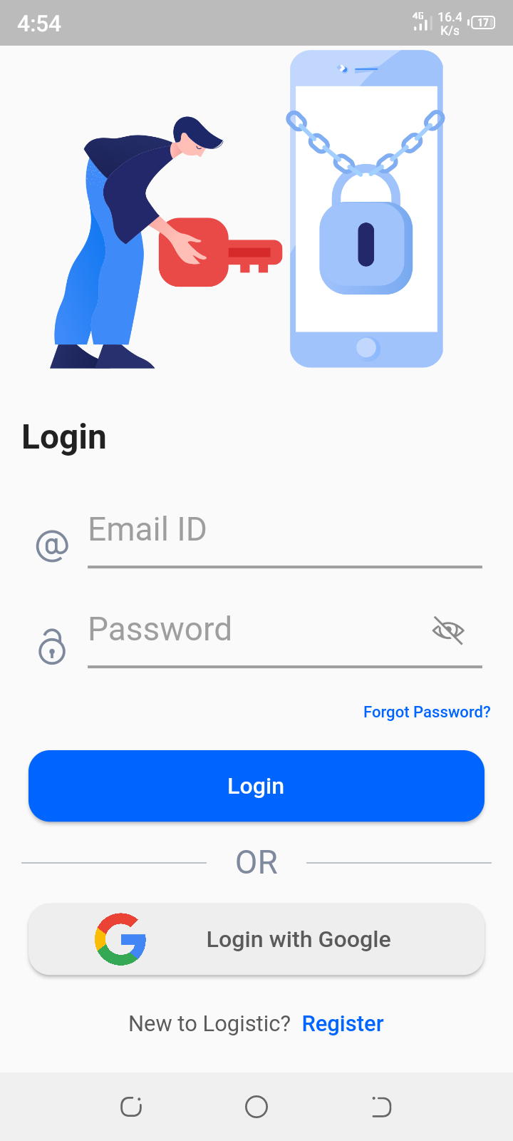

**Figure 27: Sign in mobile**

## Conclusion:

We covered the second sprint in this chapter by discussing the analysis, design and implementation of its components. The next chapter begins the third sprint.

#### 

# Chapter 5: Sprint 3

## Introduction

The objective of this chapter is to present the work completed during the third sprint of our Project. In this part, we are interested in three tasks being the sign in of the management admin, the profile management for the latter and the student and the contact admin part.

## Sprint Planning

The Sprint Planning is a collaborative work of the Scrum Team, it is the initial step of any Sprint, it lasts 4 hours, during which we set the Sprint Goal and the Sprint Backlog.

## Sprint Goal

This sprint have many goals such as ensuring the authentication of the admin, the management of his profile as well as for the student and the admin contact part.

## Sprint Backlog

Once we have defined the goal of our sprint, it's time to decide which features and features and their degree of importance are included in the sprint.

|  |  |  |  |  |
| --- | --- | --- | --- | --- |
| **User Story** | | Tasks | Owner | **Time estimated** |
| **Sprint 3** | **US 11 : As admin , i want to sign in** | create the class diagram | hajer | 1/2 Day |
| Create the Use Case Diagram | mossab | 1/2 Day |
| Create the Sequence Diagram | mossab | 1 Day |
| Manage the authentification with keycloak(Spring boot) | ahmed | 1 Day |
| Create the authentification interface (Angular) | salma | 1 Day |
| Create the sign in page for admin (Flutter) | hajer | 1 Day |
| **US 12 : As admin or student , i want to manage my profile informations** | Generate the Profile Managment Component (Angular) | salma | 2 Day |
| Build Profile managment interface (flutter) | hajer | 2 Day |
| Create Profile managment services (Node Js + Spring Boot) | ahmed + mossab | 2 Day |
| **US 13 : As student , i want to contact the admin** | Fix contact admin Back-end (Node Js) | mossab | 2 Day |
| Build the contact form (Angular) | salma | 1 Day |
| Design the Contact admin page (flutter) | hajer | 1 Day |

**Table 5: Backlog Sprint 3**

## Analysis of sprint 3

### 4.1. Use Case diagram

The use case diagram is a functional diagram that shows the interactions of the system to be interactions of the system to be developed with its users.

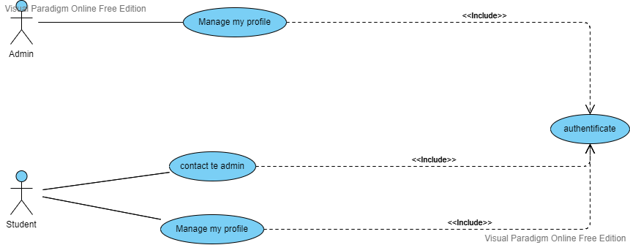

**Figure 28: Sprint 3 Use Diagram**

## Sprint 3 design

### 5.1. Class Diagram

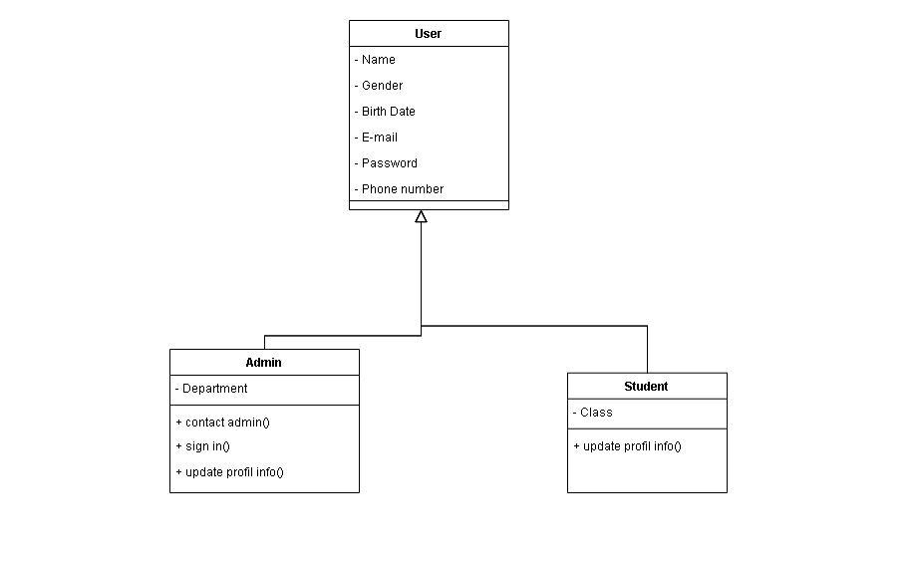

**Figure 29: Sprint 3 Class Diagram**

### 5.2. Sequence diagrams

#### 5.1.1. Sequence diagram (Update Profile):

##### 

**Figure 30: Student Participation**

**Figure 31: Update Profile**

### 5.1.2. Sequence diagram (Contact Admin):

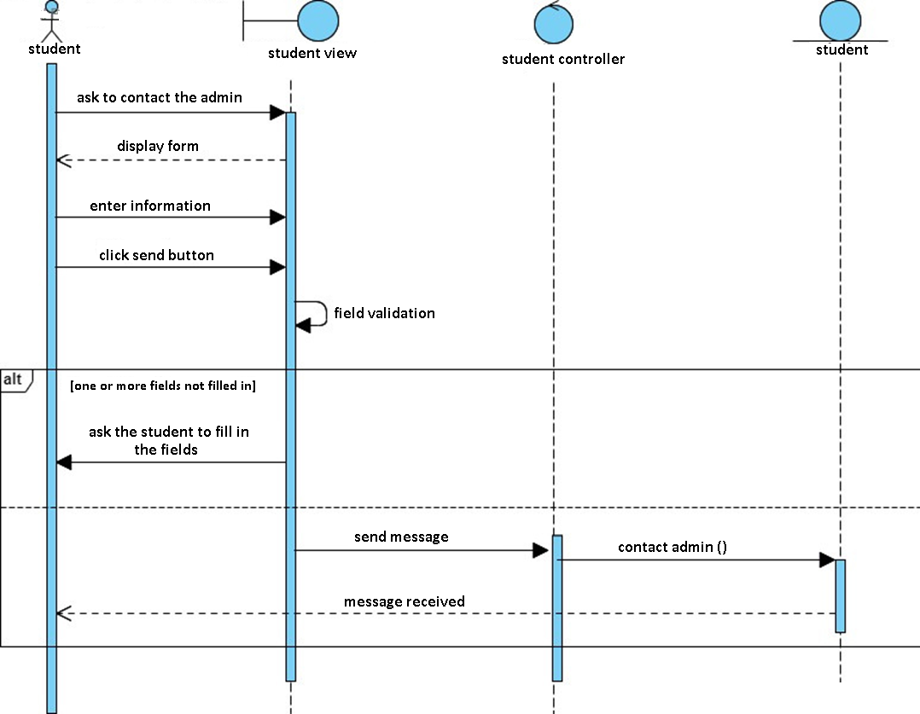

**Figure 32: Contact Admin**

## Sprint Review

The Sprint Review is held at the end of each Sprint to demonstrate the increment, inspect it and adapt the Product Backlog if necessary.

In the following, we will build the resulting increment this Sprint.

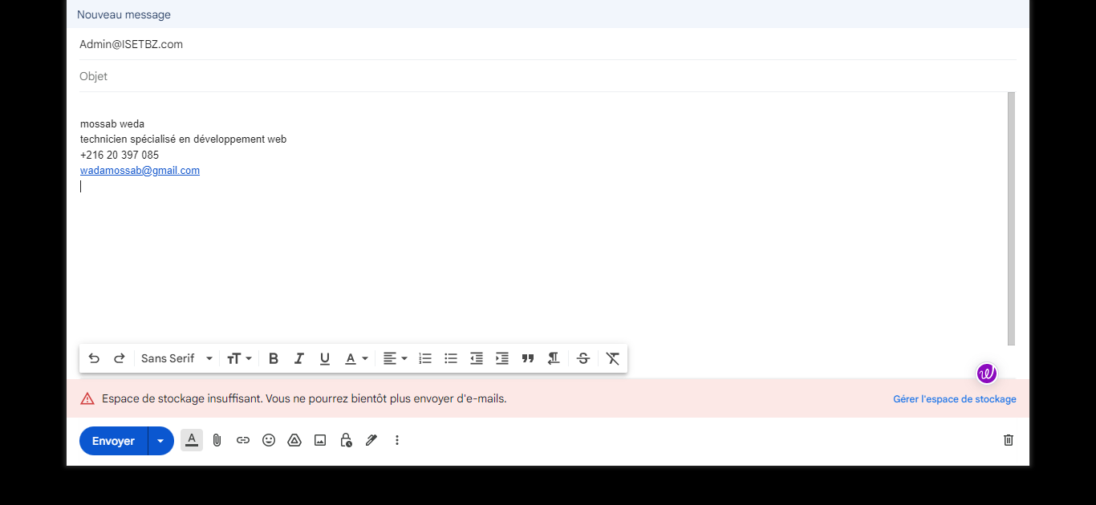

**Figure 33: Contact Admin**

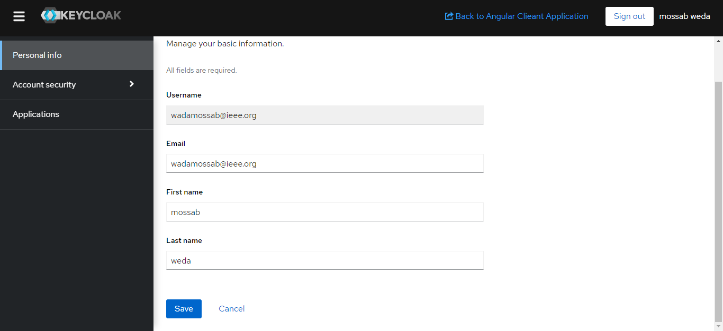

**Figure 34: home page**



**Figure 35: Contact Admin mobile**

## Conclusion:

In this chapter, we have presented the third sprint. To do this, we went through the analysis, the design, the realization of the increments. In the next chapter we start the fourth sprint.

# Chapter 6: Sprint 4

## Introduction

The objective of this chapter is to present the work completed during the fouth sprint of our Project. In this part, we are interested in two parts being the sign in of the management admin, the profile management for the latter and the student and the contact admin part.

## Sprint Planning

The Sprint Planning is a collaborative work of the Scrum Team, it is the initial step of any Sprint, it lasts 4 hours, during which we set the Sprint Goal and the Sprint Backlog.

## Sprint Goal

This sprint have many goals such as ensuring the authentication of the admin, the management of his profile as well as for the student and the admin contact part.

## Sprint Backlog

Once we have defined the goal of our sprint, it's time to decide which features and features and their degree of importance are included in the sprint.

|  |  |  |  |  |
| --- | --- | --- | --- | --- |
| **User Story** | | Tasks | Owner | **Time estimated** |
| **Sprint 4** | **US 14 : As admin i want to consult the statistics** | Create the class diagram | hajer | 1/2 Day |
| Create the Use Case Diagram | ahmed | 1/2 Day |
| Create the Sequence Diagram | mossab | 1 Day |
| Create Event-Participation micro-service (Node Js) | mossab | 3 Day |
| Design the Statistics Page (Angular) | salma | 3 Day |
| Build the satistics page with flutter | hajer | 3 Day |
| **US 15 : As student ,i want to receive notifications of new events** | Manage the notifcations (Spring boot) | ahmed | 3 Day |

**Table 6: Backlog Sprint 4**

## Analysis of sprint 4

### 4.1. Use Case diagram

The use case diagram is a functional diagram that shows the interactions of the system to be interactions of the system to be developed with its users.

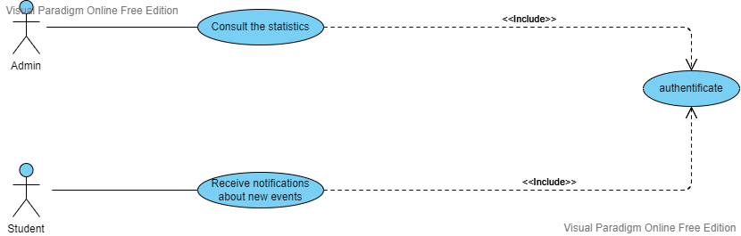

**Figure 28: Sprint 4 Use Diagram**

## Sprint 4 design

### 5.1. Class Diagram

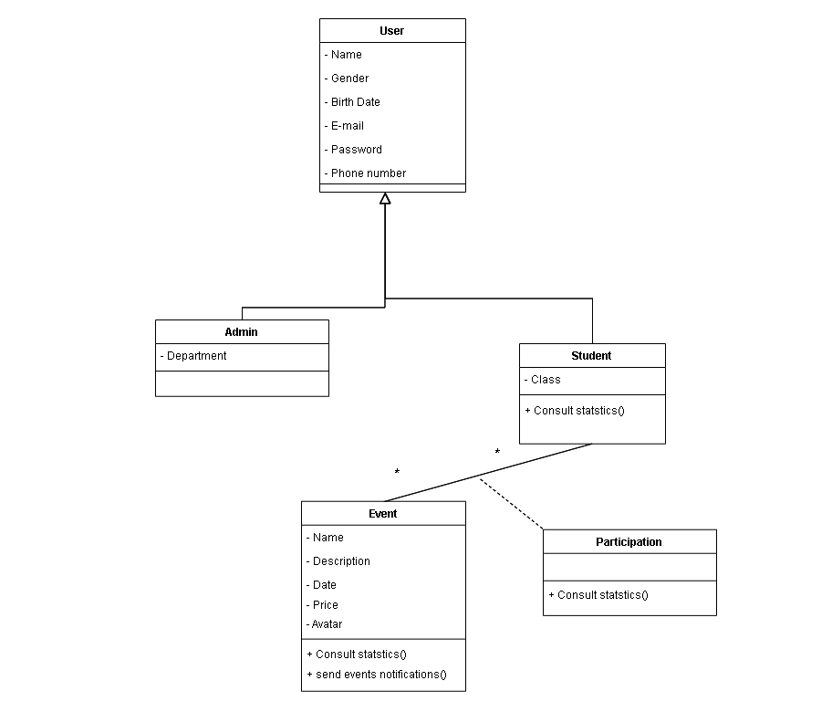

**Figure 29: Sprint 4 Class Diagram**

### 5.2. Sequence diagrams

#### 5.1.1. Sequence diagram (Update Profile):

##### 

**Figure 30: Student Participation**

**Figure 31: Update Profile**

### 5.1.2. Sequence diagram (Contact Admin):



**Figure 32: Contact Admin**

## Sprint Review

The Sprint Review is held at the end of each Sprint to demonstrate the increment, inspect it and adapt the Product Backlog if necessary.

In the following, we will build the resulting increment this Sprint.



**Figure 33: Contact Admin**



**Figure 34: home page**



**Figure 35: Contact Admin mobile**

## Conclusion:

In this chapter, we have presented the fourth sprint. To do this, we went through the analysis, the design, the realization of the increments. In the next chapter we start the fourth sprint.

# General Conclusion

It was a wonderful learning experience for us while working on this project. This project led us through the different phases of project development and gave us a real insight into the world of software engineering. The joy of working and the thrill of solving different problems and challenges gave all of us a sense of the developer industry.

It was through this project that we learned how professional software is designed while working as a team.

# Bibliography and Neography

**[1]** [**https://www.w3schools.com/**](https://www.w3schools.com/)

**[2]** [**https://getbootstrap.com/**](https://getbootstrap.com/)

**[3]** [**https://angular.io/**](https://angular.io/)

**[4]** [**https://www.youtube.com/**](https://www.youtube.com/)

**[5]** [**https://stackoverflow.com/**](https://stackoverflow.com/)

**[6]** [**https://icons.getbootstrap.com/**](https://icons.getbootstrap.com/)

**[7]** [**https://keycloakthemes.com/**](https://keycloakthemes.com/)